

**JFK (JOY FOR KIDS) UNIVERSAL FOUNDATION DONATION AND SHOPPING CART SYSTEM**

USER MANUAL – FRONT END

MEMBERS:

LOIS ANNE G. LOGRONIO

KATHARYN ALEXANDRE D. MAYO

RENON ERROL C. DADULLA

IT-111

TABLE OF CONTENTS

1. **HOME PAGE**

1.1 Home Page

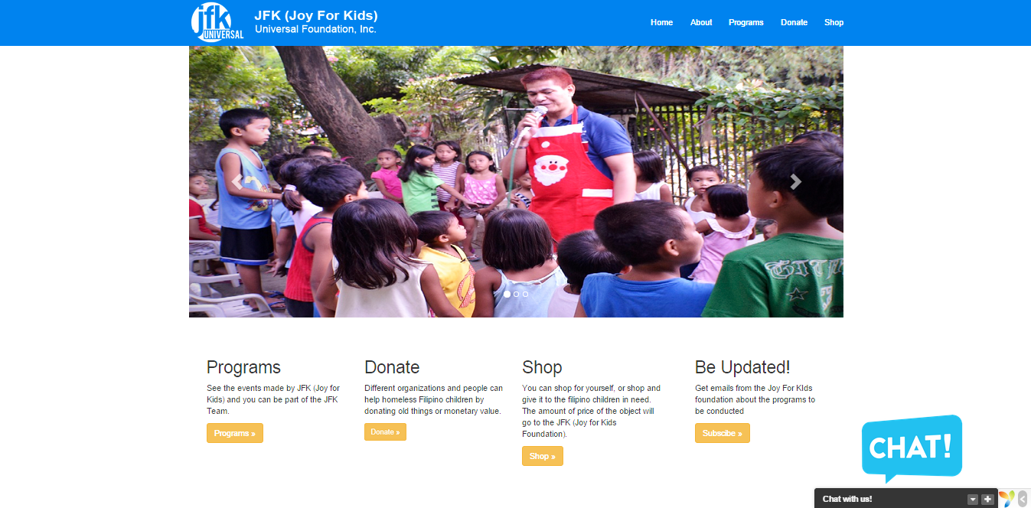

* In this screen shot, it shows all the things that can be done in the website, and it also shows all of our modules that we have done for our project.

1. **ABOUT PAGE**

2.1 HOME PAGE GOING TO ABOUT PAGE

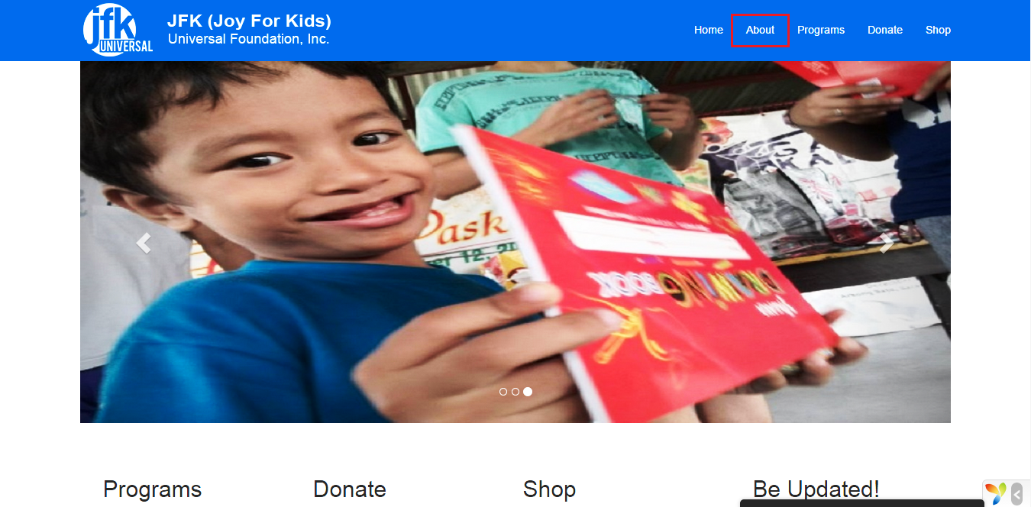

* When going to the about page, we can see the “ABOUT” tab in the header of site which has a red rectangle drawn to it.

2.2 ABOUT PAGE

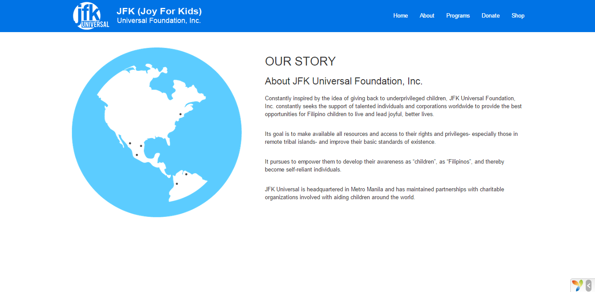

* In this screen shot, we can see the story of the company and how it was founded and what the purpose of in creating a foundation.

1. **PROGRAM PAGE**

3.1 Preview of Program Page

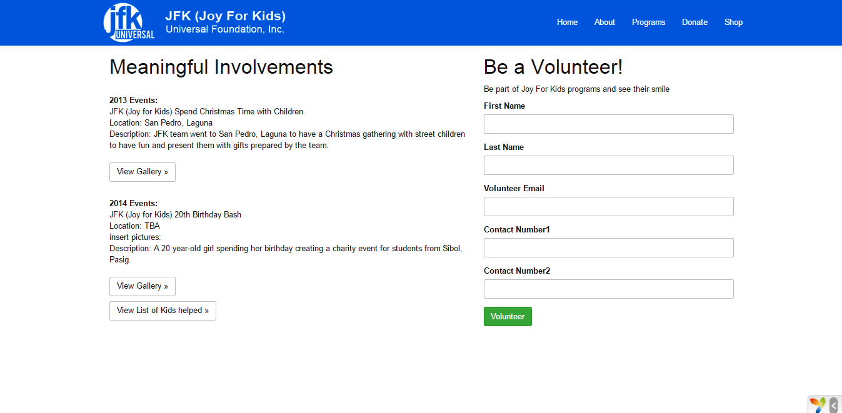

* In this page, we can see the past events created, and on the right side we can see that clients or customers can volunteer for events and help out in JFK (Joy for Kids).

3.2 Preview of Gallery Page

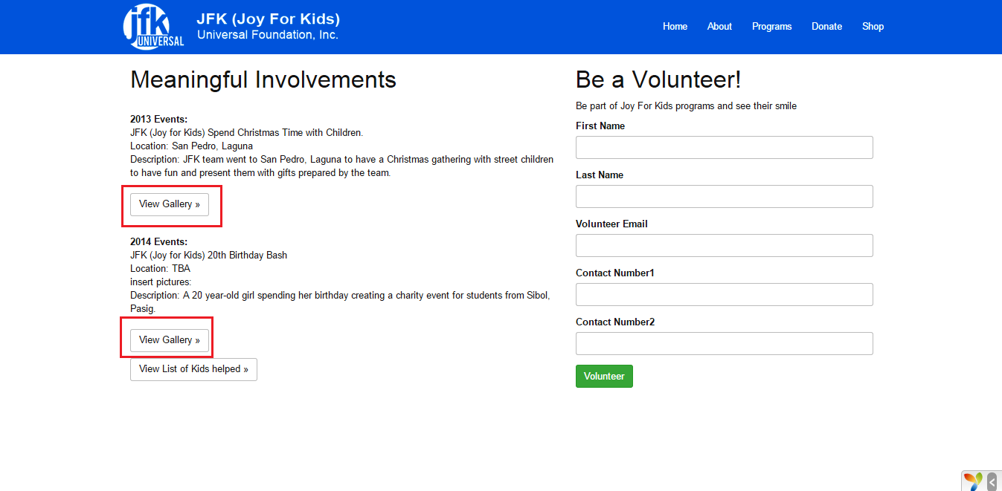

* In clicking on the “View Gallery”, it will redirect to a page were you can see pictures of the said event.

3.3 One of the Gallery Pages

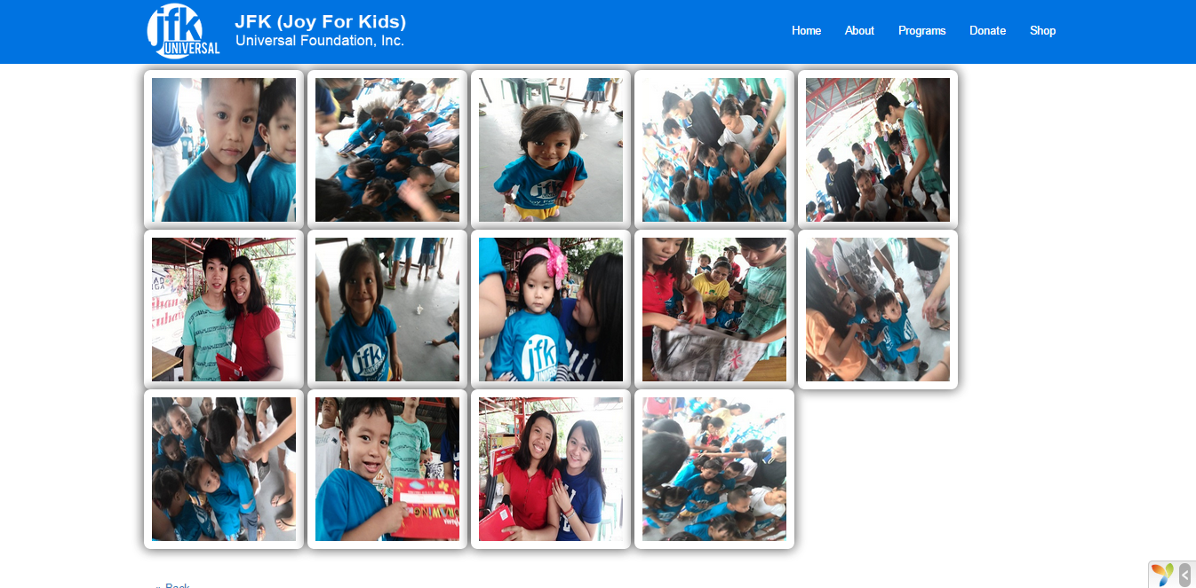

3.4 Example of an Enlarged Picture

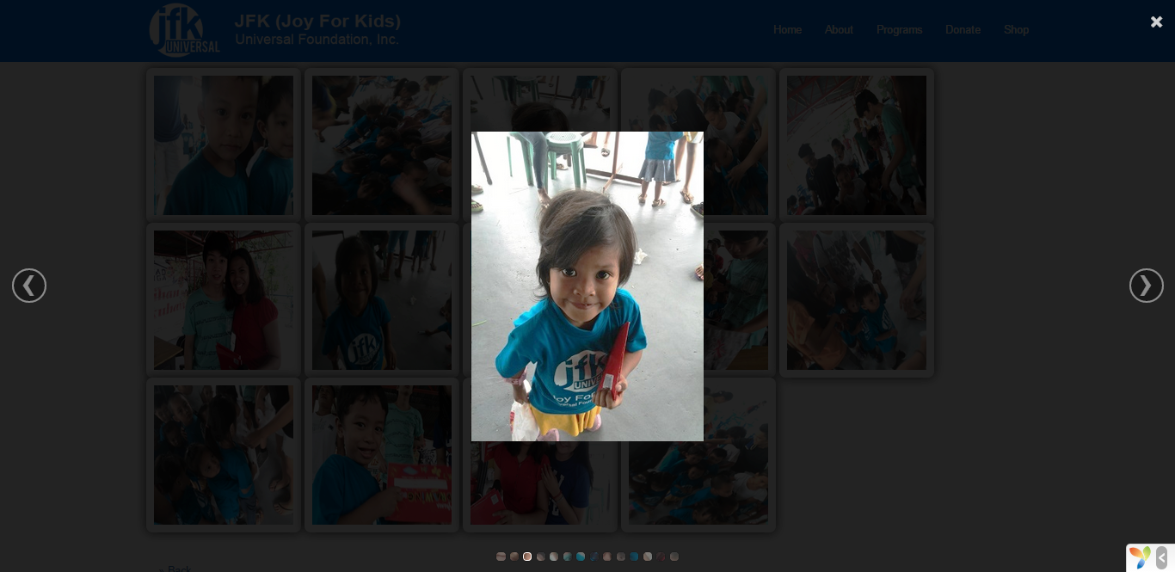

* As shown here, these are pictures from one of the events created by JFK (Joy for Kids). Clients and customers can hover and click one of the pictures and I will enlarge.

3.4 Volunteer Preview

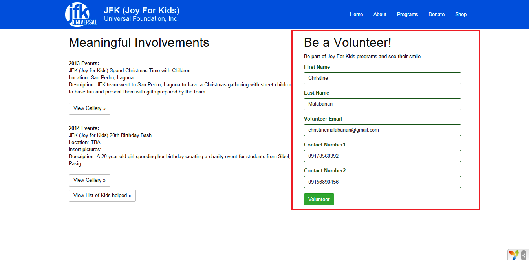

* The one drawn in the red square is one of our modules, which clients and customers can volunteer for the events they want to join for. When the client or customer clicks volunteer, the details of the client or customer will go to the back end (admin side) of the system.

1. **DONATE PAGE**

4.1 Donate Page

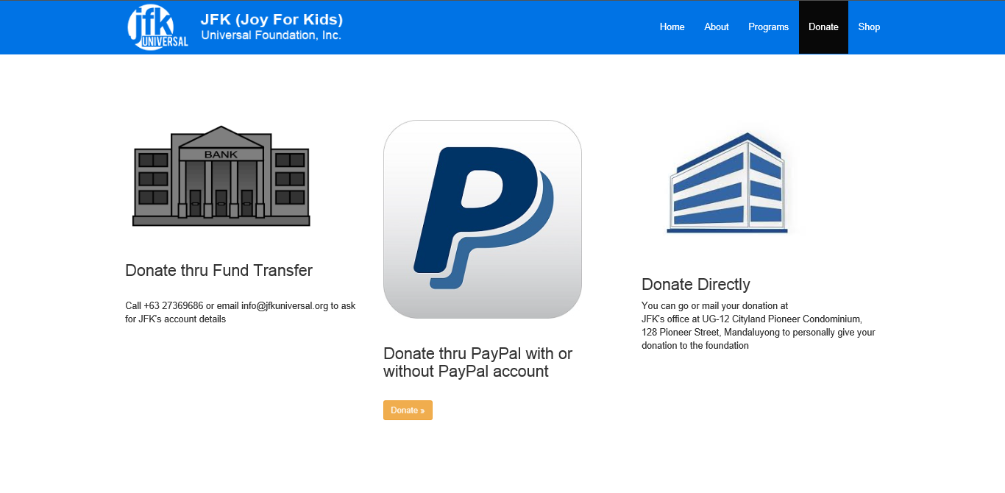

* Shown above are the three ways to donate to the Joy For Kids Foundation. First is through fund transfer where donators will have to contact the office first to know the account details of the foundation. Second is through PayPal where the user will be redirected to PayPal site and lastly is the donator will have to go directly to the office of the foundation. Donator may also mail it in the address written above. This is convenient for material things to be donated.

4.2 PayPal Page

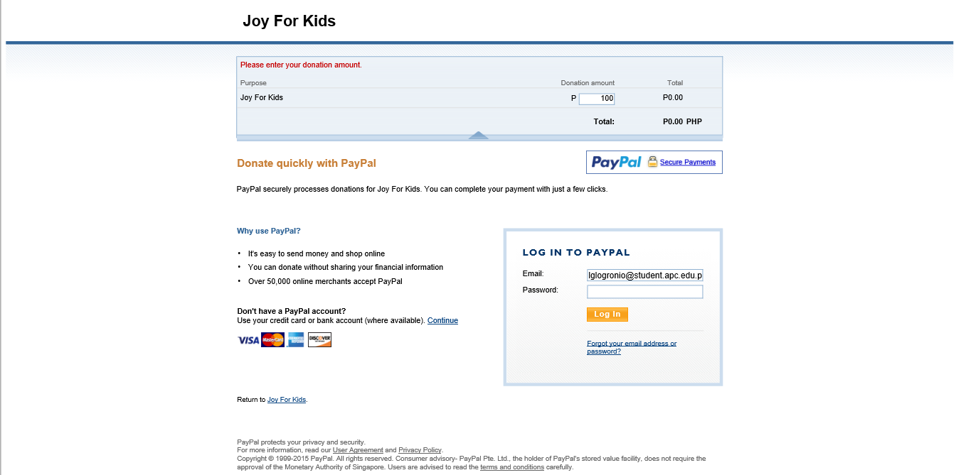

* User will have to put the amount of donation in the text field then click to continue if he/she doesn’t have a PayPal account. If the user has a PayPal account he/she may login.

4.3 PayPal billing Details

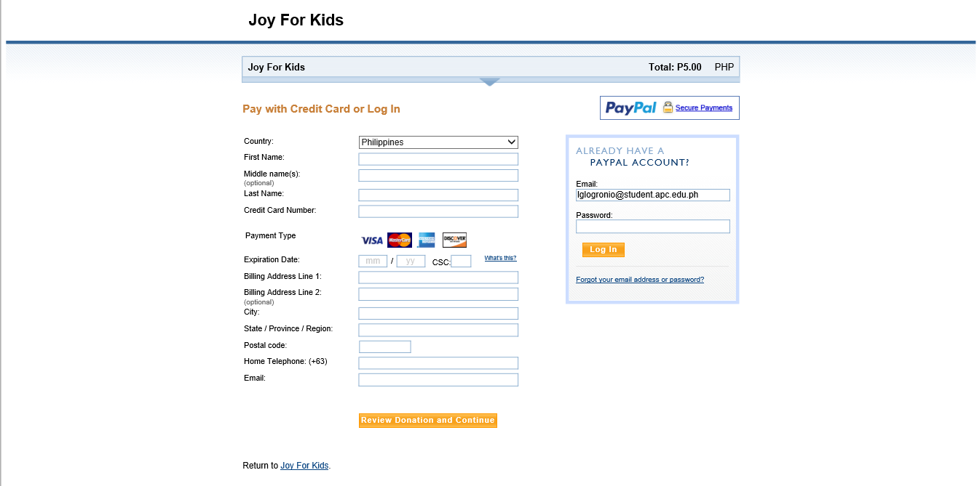

* For those who do not have a PayPal account, he/she must enter the personal information and credit/debit card details.

4.4 PayPal Itinerary Page

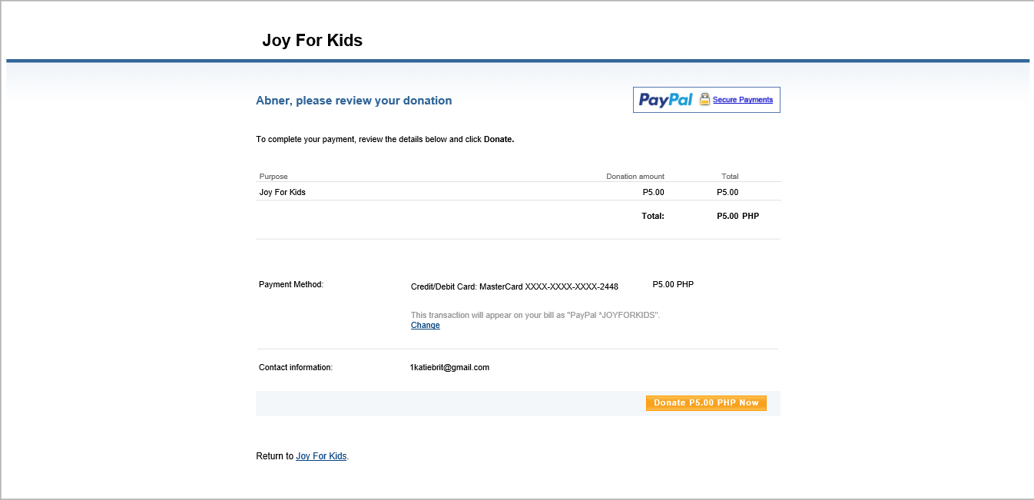

* Displays the total donation of the user, payment method, and email of beneficiary.

1. **SHOP PAGE**

5.1 Shop Page

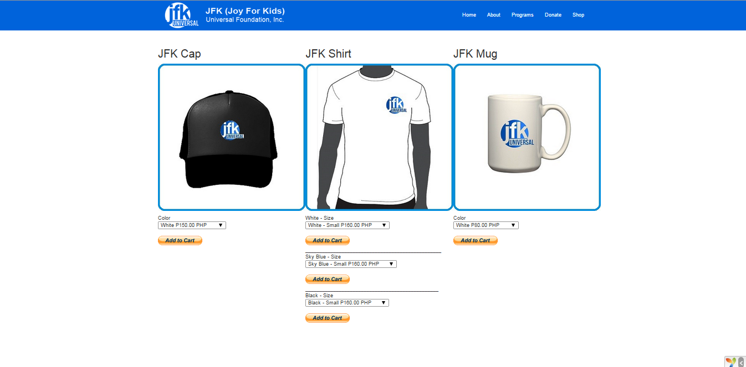

* Displays the items to be sold by the foundation. Once the Add Cart button is clicked, the user will be redirected to PayPal site.